

THE UNIVERSITY OF AZAD JAMMU AND KASHMIR, MUZAFFARABAD
Department of Software Engineering

Submitted to: | Engr. Asma Javed
Course Title: | Data Structure and Algorithm
Course Code: | CS-2101
Session: | 2024-2028
Lab No: | 09
Roll No: | 2024-SE-15
Submitted By: | Shahzad Ahmed Awan
Submission date: | January 9, 2026

Table of Contents
Lab 09: Implementation of Tree Data Structure in C++ 3
Objective 3
Tools Used 3
Theory (Minimal) 3
Implementation Details 3
1. Node Creation 3
3. Inorder Traversal 4
4. Preorder Traversal 4
5. Postorder Traversal 4
6. Search Operation 5
7. Counting Nodes 5
8. Height of Tree 5
9. Memory Deallocation 6
10. Main Function Stimulation: 6
Output of the Above Stimulation & Implementation: 7
Result 7
Conclusion 7

Table of Figure
Figure 1:Blueprint for Node Creation 3
Figure 2: Function for creating Node 3
Figure 3: Function for Inorder traversal 4
Figure 4: Function for Preorder Traversal 4
Figure 5: Function for Postorder Traversal 4
Figure 6: Function for Search Operation 5
Figure 7: Function for Counting Nodes 5
Figure 8: Function for Height Calculation 5
Figure 10: Function for Deleting a Tree 6
Figure 9: All Stimulation Code in the main Function 6
Figure 11: Output of the Above Stimulation & Implementation 7

Lab 09: Implementation of Tree Data Structure in C++

Objective
To implement a Binary Tree in C++ and perform basic tree operations.

Tools Used
- Dev C++

Theory (Minimal)
A Tree is a non-linear data structure used to store data in hierarchical form.
A Binary Tree allows at most two children for each node.

Implementation Details

1. Node Creation
Used a structure to store data and pointers to left and right child.
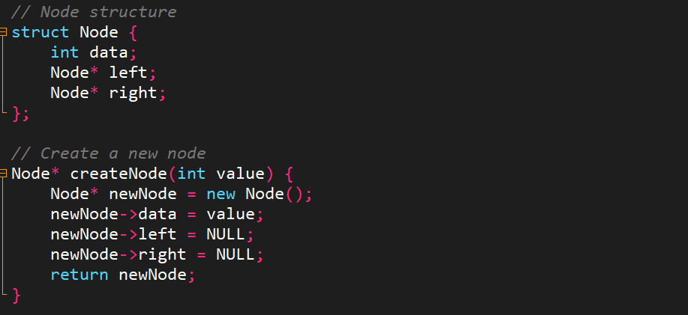
Figure 1:Blueprint for Node Creation
2. Create Node Function
A function is used to dynamically create and initialize a new node
Figure 2: Function for creating Node

3. Inorder Traversal
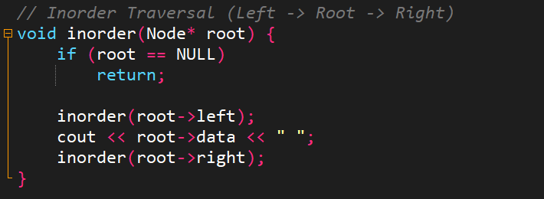
Traversal order: Left → Root → Right
Figure 3: Function for Inorder traversal

4. Preorder Traversal
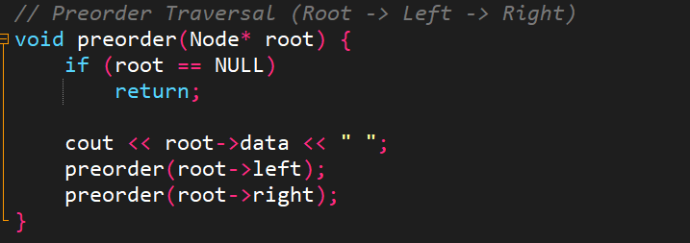
Traversal order: Root → Left → Right
Figure 4: Function for Preorder Traversal

5. Postorder Traversal
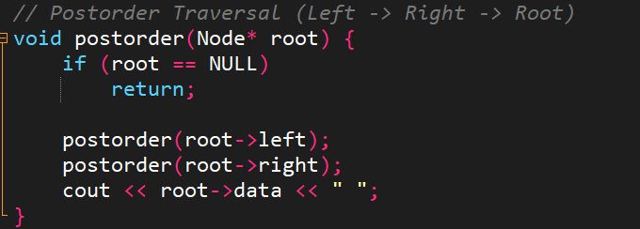
Traversal order: Left → Right → Root
Figure 5: Function for Postorder Traversal

6. Search Operation
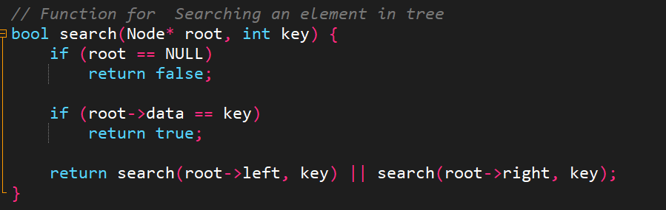
Used recursive approach to search an element in the tree.
Figure 6: Function for Search Operation

7. Counting Nodes
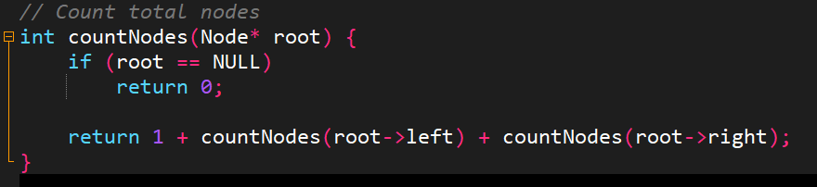
Function used to count total nodes in the tree.
Figure 7: Function for Counting Nodes

8. Height of Tree
Height is calculated using recursive comparison of left and right subtrees.
Figure 8: Function for Height Calculation
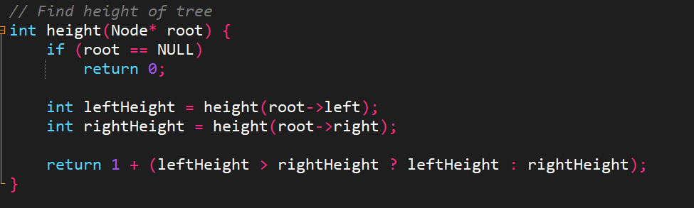

9. Memory Deallocation
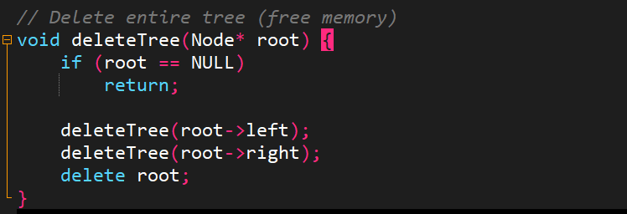
All nodes are deleted using postorder traversal to avoid memory leakage.
Figure 9: Function for Deleting a Tree

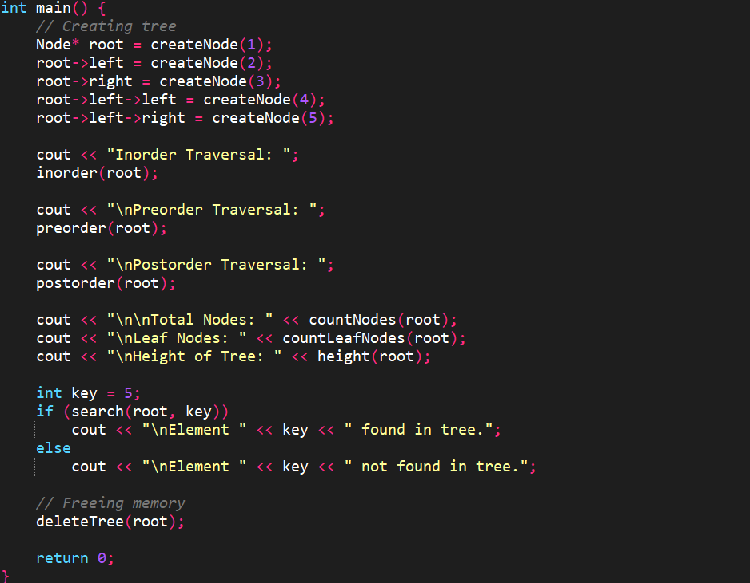
10. Main Function Stimulation:
Figure 10: All Stimulation Code in the main Function

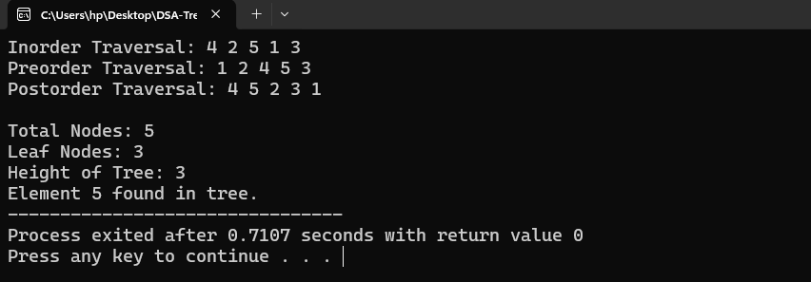
Output of the Above Stimulation & Implementation:
Figure 11: Output of the Above Stimulation & Implementation

Result
The Binary Tree was successfully implemented and all operations worked correctly.

Conclusion
Tree operations including traversal, searching, counting, and height calculation were implemented successfully using C++.

